Cisco NSO:

Network Services Orchestrator

Cisco NSO is model-driven with services and device configurations specified in declaration YANG data models.

**Objective of NSO:**

Inside the devices (Physical or Virtual), we need to push the services.

**Advantages of NSO:**

Bring services to market faster.

Improve your service agility

Advance new Revenue opportunities.

Enhance operational efficiency.

**NSO Architecture :**

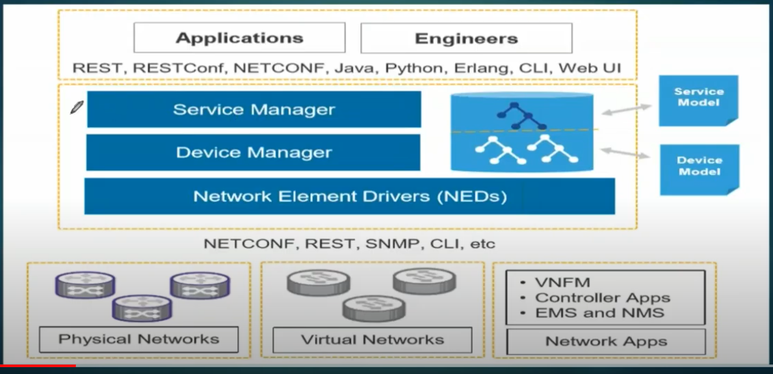

**NSO 2 main layers :**

* Device Manager
  + To manage diffèrent devices in a uniform and generic way.
  + Device manager uses the Device Models written in YANG and provided by the network Element Drivers, NEDs
* Service Manager
  + Service Manager lets you use and define service-aware applications, such as L2VPN, L3VPN etc
  + Each service app is a package of its own and loaded to NSO.
  + Services can e modified and reloaded to a system.
  + Service Manager supports the full lifecycle for a service: creating, deleting and editing etc.

Module 🡪 Single python file (.py)

Package 🡪 Folder which consist of python files.

Netcon

Yang Model

Cisco Devnet:

Cisco platform for developers.